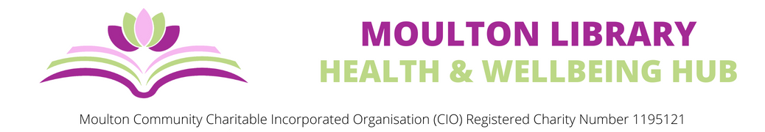
Supporting Information for Trustee Applications
Why Become a Trustee for the CIO
Moulton Library, Health and Wellbeing hub is located within the newly built Moulton Community Centre. The doors opened in May 2017 and by November 2017 was threatened by closure, by the now defunct, Northamptonshire County Council. Following a lengthy campaign Moulton Parish Council purchased the library from NCC and Moulton Community Managed Library (CML) was born.
The purchase of the library supported the aims of Moulton Parish Council to establish a base in order to continue to deliver a comprehensive Health and Wellbeing Strategy to residents in Moulton and the surrounding communities. Since 2015, Moulton Parish Council has been working in partnership with the local G.P. Surgery to deliver a whole range of holistic activities and events.
About Moulton Library, Health and Wellbeing Hub
Our aim is to promote for the benefit of the residents of Moulton and surrounding communities the provision of a public library for recreation, education and other leisure time occupations of individuals who have need of such facilities, and;
To promote for the benefit of the residents of Moulton and surrounding communities the provision of health and wellbeing services, with the object of improving the condition of life and supporting individuals as necessary
The Hub, located within the Community Centre is used as a home for groups, meeting space with an extensive café menu. The building is open seven days each week, with the Hub used as a ‘Warm Hub’ providing free hot drinks and snacks.
Alongside this we are able to provide a home for learning and growing, teaching, recreational hobbies, health education, economic and community development, promoting of volunteering, crime prevention and more
As a CIO we can attract a variety of grant funding to further develop and maintain our service delivery. We can train our staff, ensuring high standards of practice and providing comfort
The CIO helps residents of all ages living within the specified geographical area of Moulton and the surrounding communities. The population of Moulton alone has grown by 68% in the last six years.
We form close links with local educational establishments and local groups sharing information amongst the community through the parish magazine, Moulton Scene, which is delivered through every door in the geographical area and through social media and our extensive website

Who are we
The Board of Trustees
Stephen Fehnert
Geoff Paul
David Aarons
Jane Austin
Yvonne Swallow
We are always looking for new Trustees to join the Board who have the skills, knowledge, experience and commitment to assist the organisation build on its achievements, continue to meet its objectives and provide a sustainable future.
Trustee roles are voluntary and unremunerated although expenses related to meeting the duties of the role can be covered and we will support Trustees through formal and informal training
Role Summary
Trustees have responsibility for making decisions including oversight of:
- Governance
- Financial management, budgets and investments
- Health and Safety, Safeguarding and HR policies and procedures
- Fundraising
- Act in the best interests of the charity, impartially and without bias
- Use specific skills, knowledge and experience to help the Board of Trustees reach sound decisions
How much time would you expect to give
- Board meetings are held several times each year, usually in the late afternoon and will last approximately 30 minutes.
- Attend the AGM once a year, usually in May
- Board members would preferably need to serve a minimum of three years
Equality and Diversity
Moulton Library, Health and Wellbeing Hub is committed to Equal Opportunities and championing diversity and inclusion. We positively welcome applications from people from all backgrounds
Trustee Myth-Busting
There can be several misconceptions about what’s needed to be a Trustee, so we thought we’d bust some of those myths!
Myth One – YOU HAVE TO BE INVITED TO BE A TRUSTEE: This isn’t true, we advertise our Trustee roles both internally and externally and welcome applications from people we haven’t met yet
Myth Two – YOU ARE PERSONALLY LIABLE IF THINGS GO WRONG – Don’t worry, this is not true. Personal liability is limited to £1 per Trustee, meaning that even if the charity were to close you would not have to personally pay any debts. Legal responsibility requires you to act with honesty, integrity, in the best interests of the charity and without any conflict of interest
Myth Three – I DON’T FIT THE IMAGE OF WHAT A TRUSTEE SHOULD BE: There is no right or wrong image of what a Trustee is – old, young, male, female, non-binary, formal or informal etc. Our Board aims to represent the wide range of communities we serve. This means we want our Trustees to be a mixture of ages, gender, ethnicity, knowledge, social background, skills and lived experiences
Myth Four – I’M NOT THE TYPE OF PERSON WHO WOULD MAKE A GOOD TRUSTEE: There are so many talented, experienced and passionate people who would make the perfect Trustee, by who count themselves out because they don’t consider themselves confident or experienced enough. Your perspective could be the very thing that can change an organisation for the better. Please don’t count yourself out

If you have any questions about your suitability, please contact
info@moultonparishcouncil.org.uk
Why not visit us?
Our address is Moulton Library, Health and Wellbeing Hub, Moulton Community Centre, Sandy Hill, Reedings, Moulton, Northampton, NN3 7AX
In person: you can arrange a meeting for an informal chat by emailing info@moultonparishcouncil.org.uk
How do you apply
Please email your completed application form together with a covering letter highlighting your relevant experience and why you want to be a Trustee, send your application to info@moultonparishcouncil.org.uk

